### Estimation of Business Expenses

### 1. Introduction:

*Business expenses are costs associated with running a company. When you know all of a company’s expenses, you can create a more accurate budget and track spending. Expenses are also a part of a company’s income sheet. You must know a business’s expenses to calculate a final net profit. Costs are subtracted from revenue to determine a company’s taxable income. Accountants and financial leaders can use these expenses to create a company budget, produce income statements or file tax reports. Understanding a company’s expenses and knowing which ones are tax-deductible can also help you prepare a company’s taxes.

### 1.1 Overview

***1.1.1 Objectives:***

* This involves estimating all the expenses required to start and operate the business, such as equipment, rent, inventory, and marketing.

* By calculating these costs upfront, business owners can better plan their budget and avoid unexpected expenses.

*Business expenses are costs associated with running a company.

*Calculating your business startup costs before you launch is an important step in setting up a small business.

**1.1.2 Methodology:**

**\* Operating Expenses:** Operating expenses are the expenses related to the company’s main activities, such as the cost of goods sold, administrative fees, office supplies, direct labor, and rent. These are the expenses that are incurred from normal, day-to-day activities.

**\*Non-operating Expenses**: Non-operating expenses are not directly related to the business's core operations. Common examples include interest charges and other costs associated with borrowing money.

**\* Capital Expenses**: Capital expenditures, commonly known as CapEx, are funds used by a company to acquire, upgrade, and maintain physical assets such as property, buildings, an industrial plant, technology, or equipment.

2. Problem Defination & Design Thinking:

**2.1. Empathy map:**

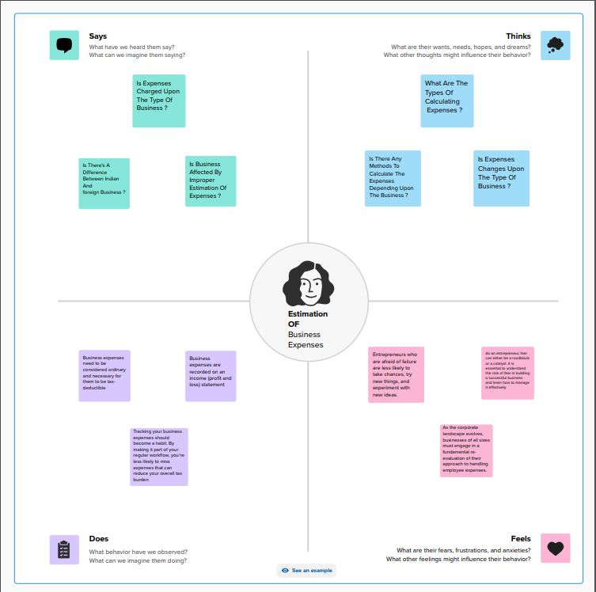

**2.2. Ideation & Brainstorming map:**

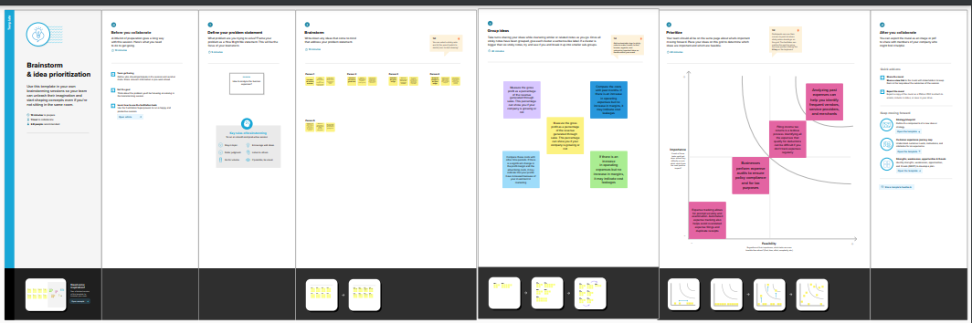

**3. Result:**

The available dataset opens the door to an array of unique visual depictions. Employing diverse visualization techniques like bar charts, line charts, heat maps, scatter plots, pie charts, maps, and others, provides a versatile toolkit for delving into project performance and efficiency. These visual representations serve multiple functions, including performance comparison, temporal trend analysis, and showcasing the distribution and relationships between variables.

### 3.1 Visualizations

Annual Payroll:

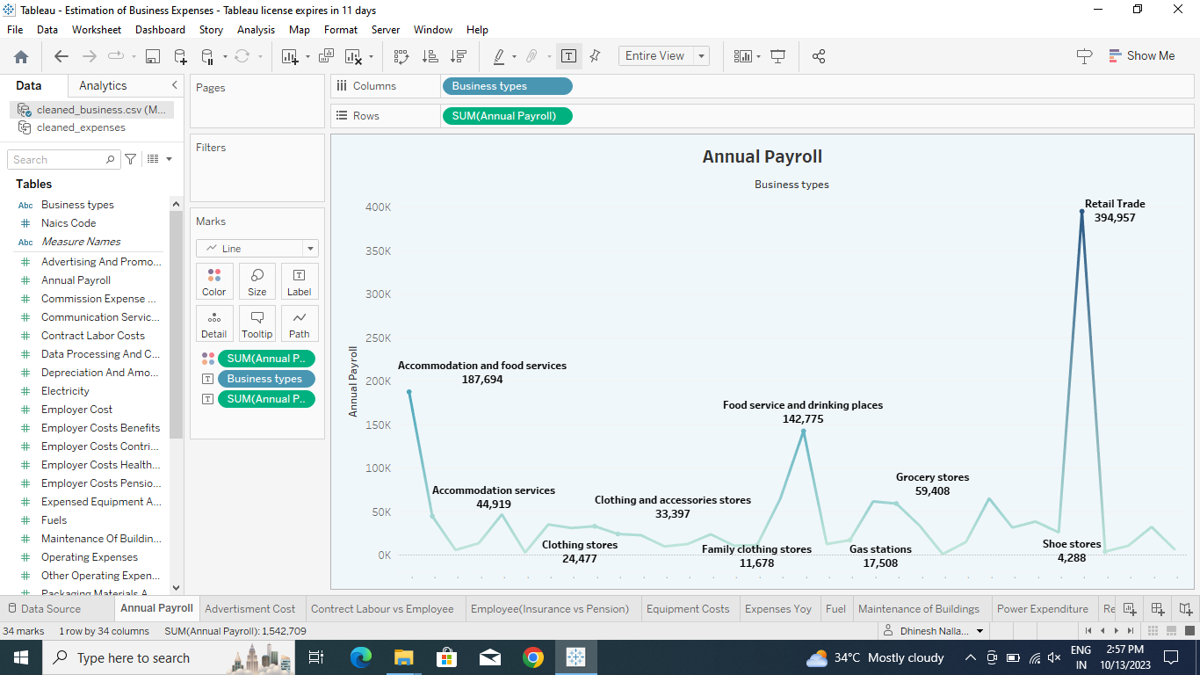

**Advertisment Cost**

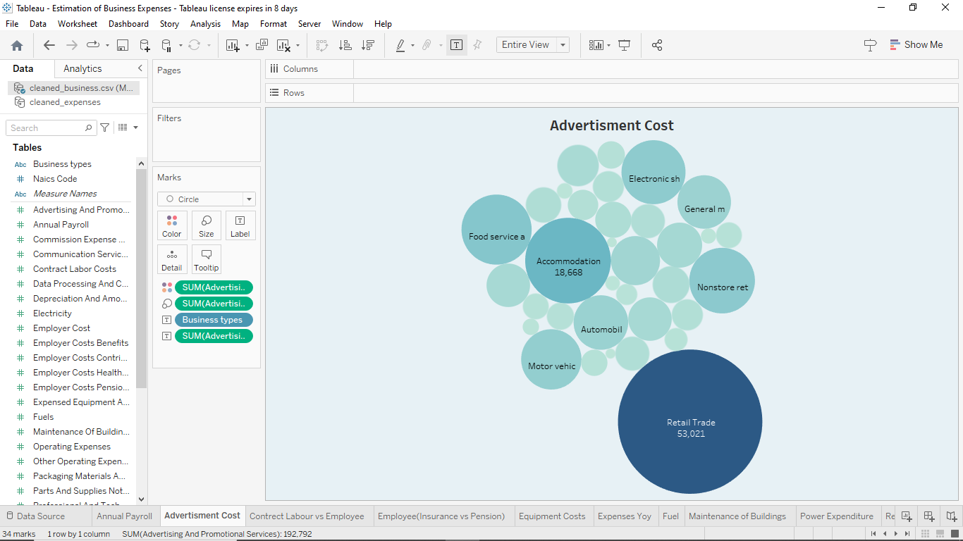

**Contrect Labour vs Employee:**

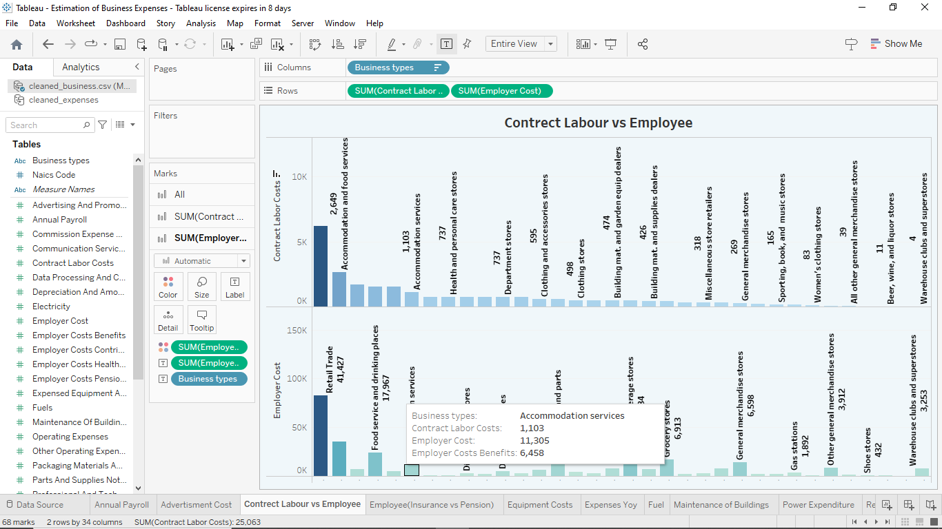

**Employee (Insurance vs Pension):**

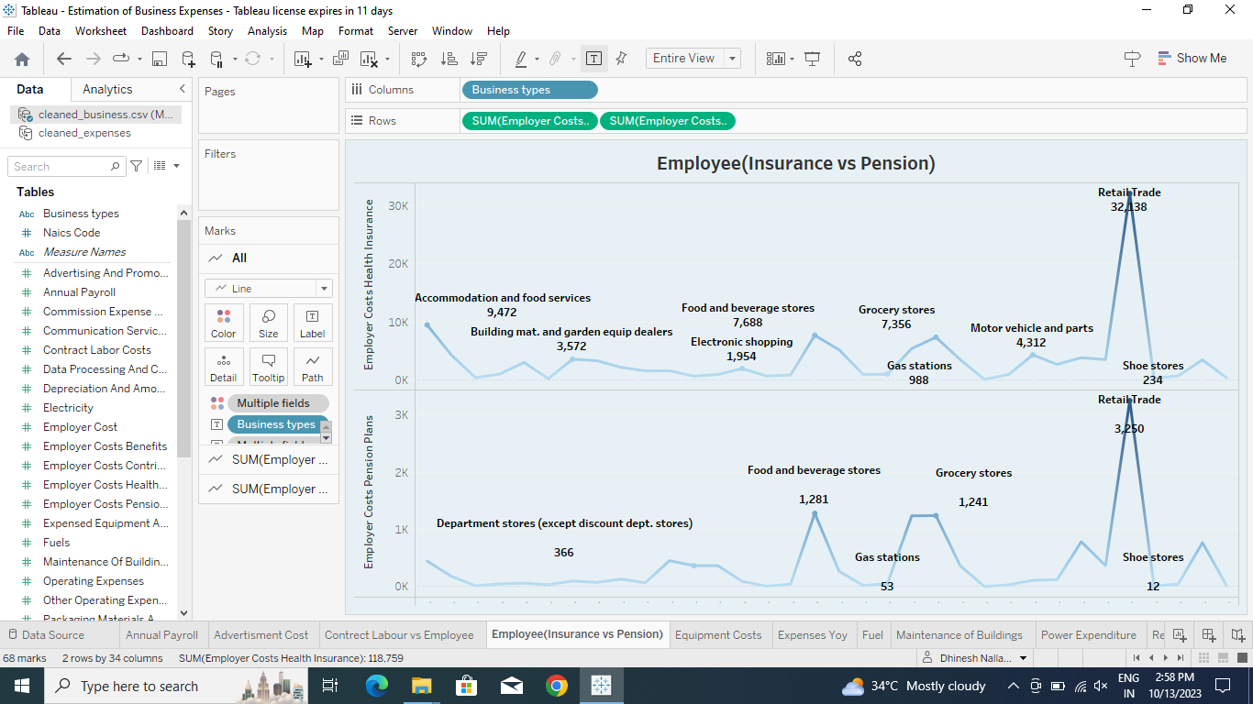

**Equipment Costs:**

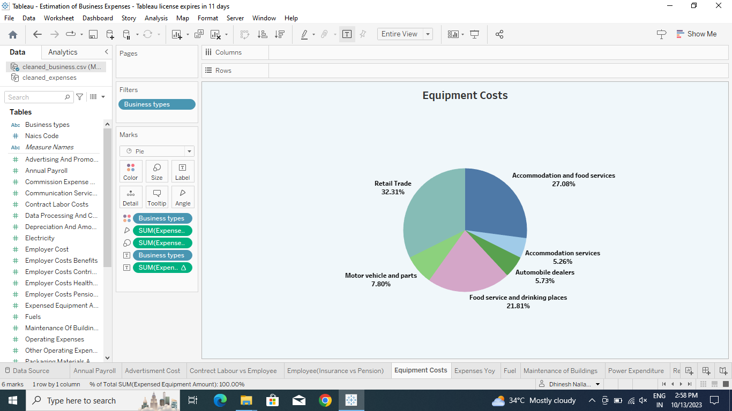

**Expenses Yoy:**

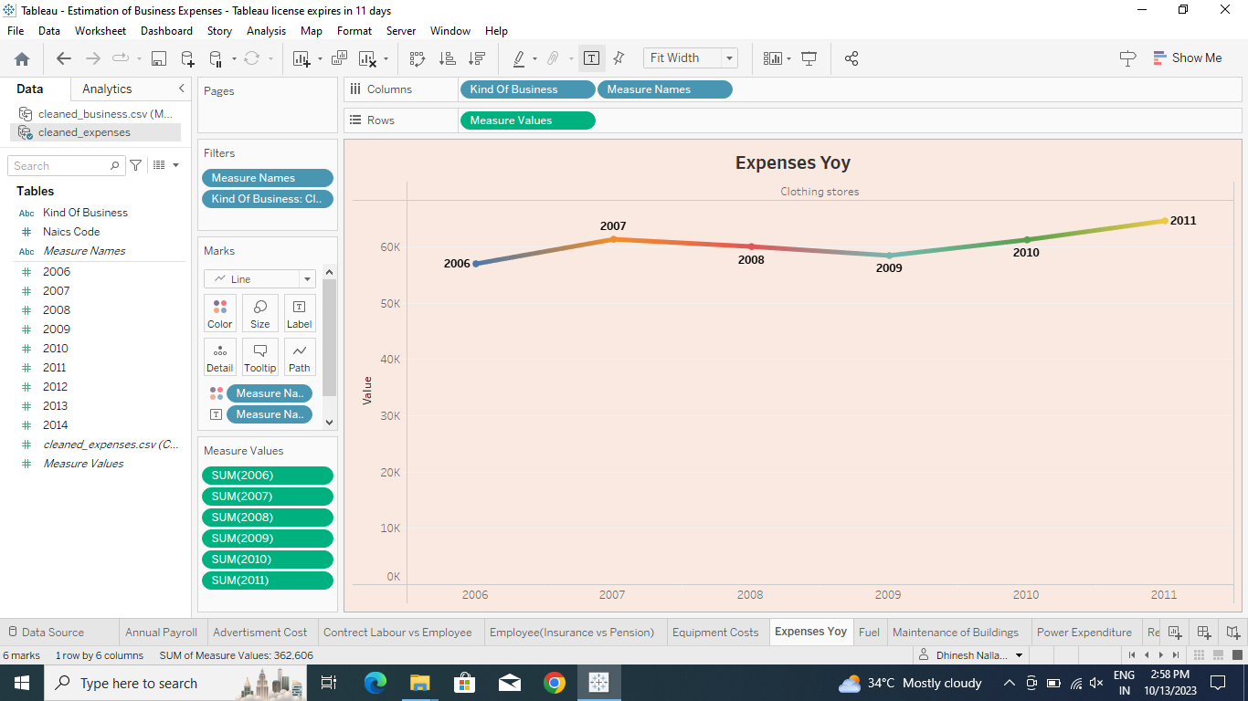

**Fuel:**

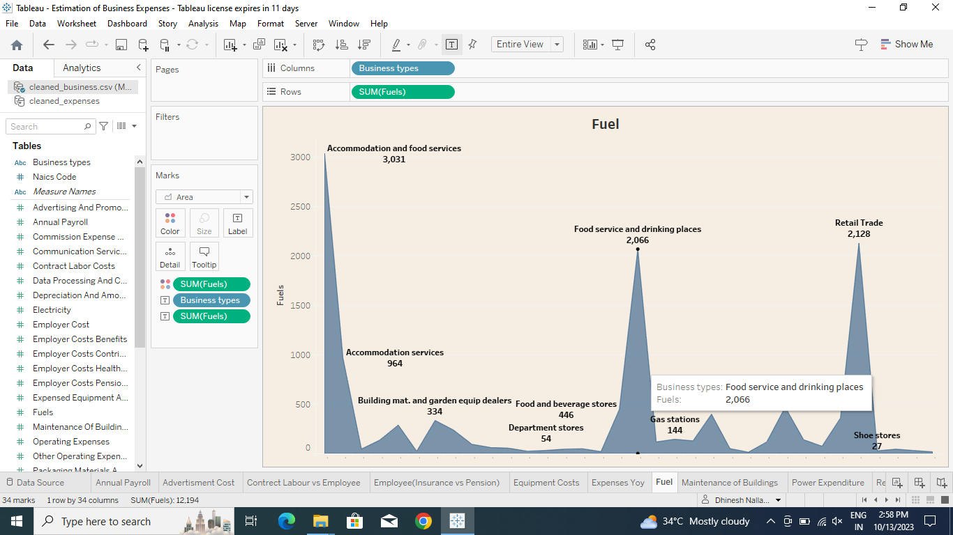

**Maintenance of Buildings:**

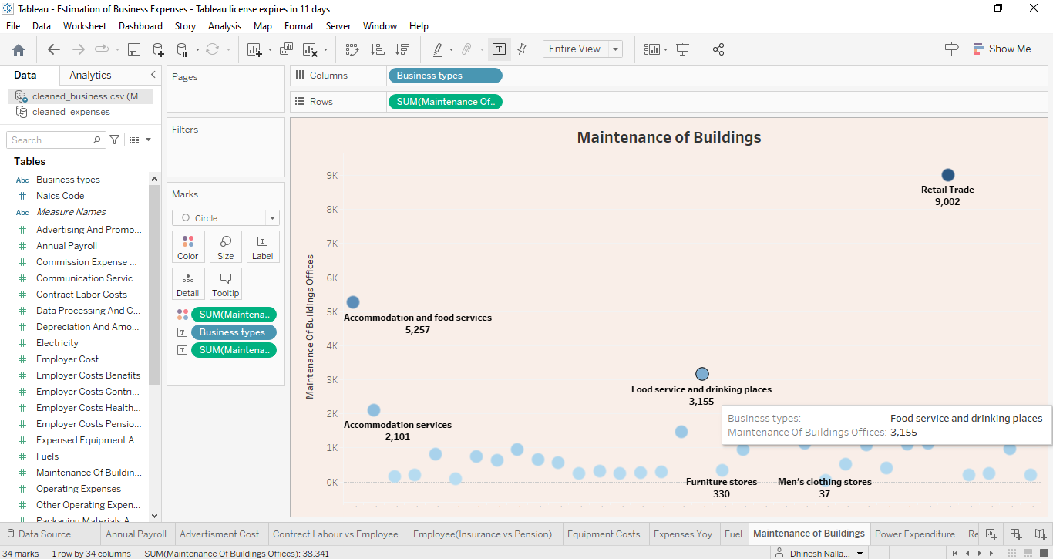

**Power Expenditure:**

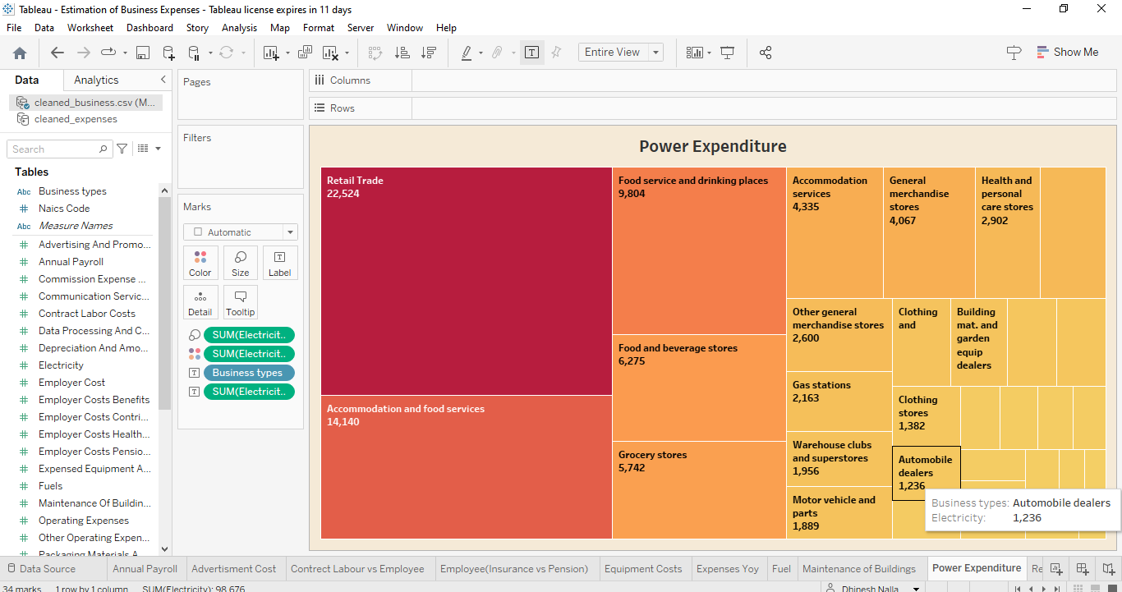

**Rental Payment Machinery:**

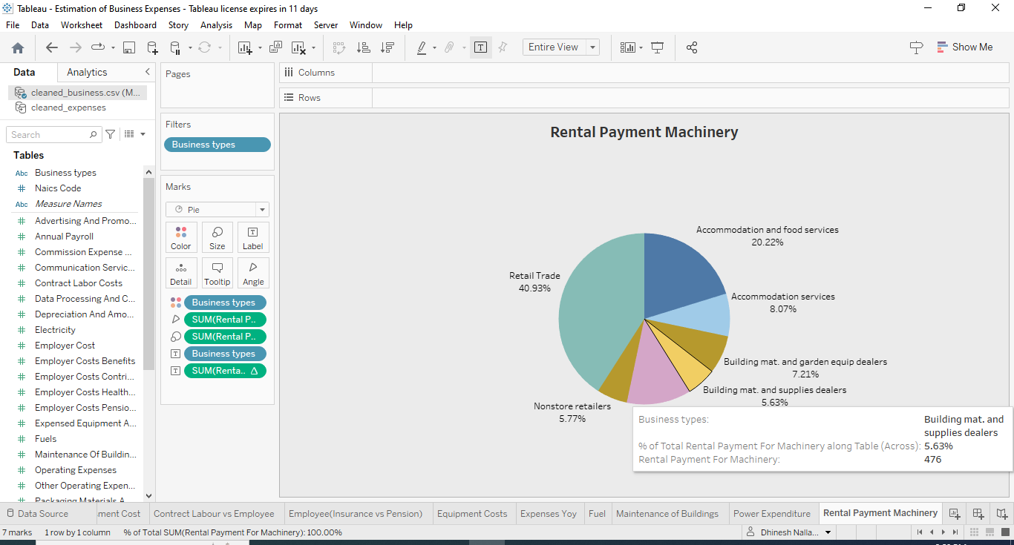

**Taxes and Licenses:**

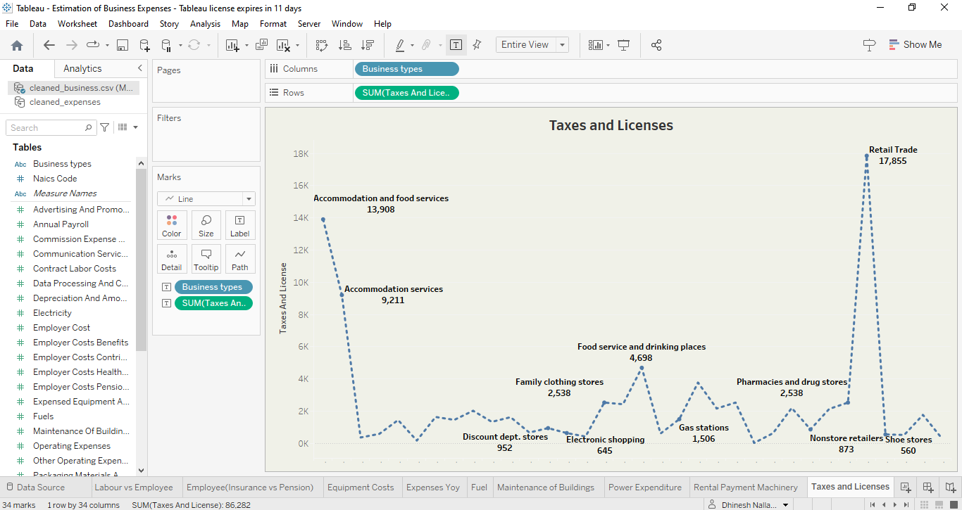

**Transportation and Warehousing:**

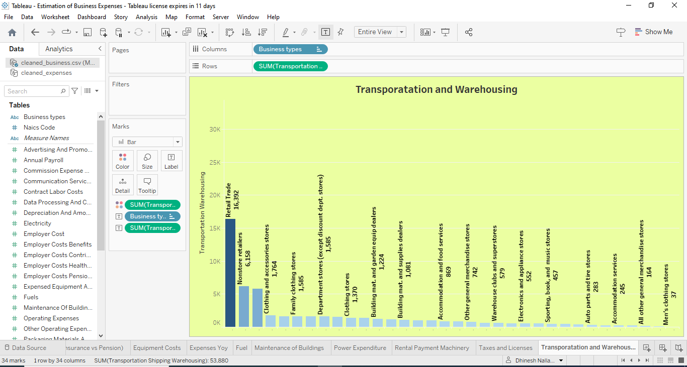

### 3.2. Dashboard

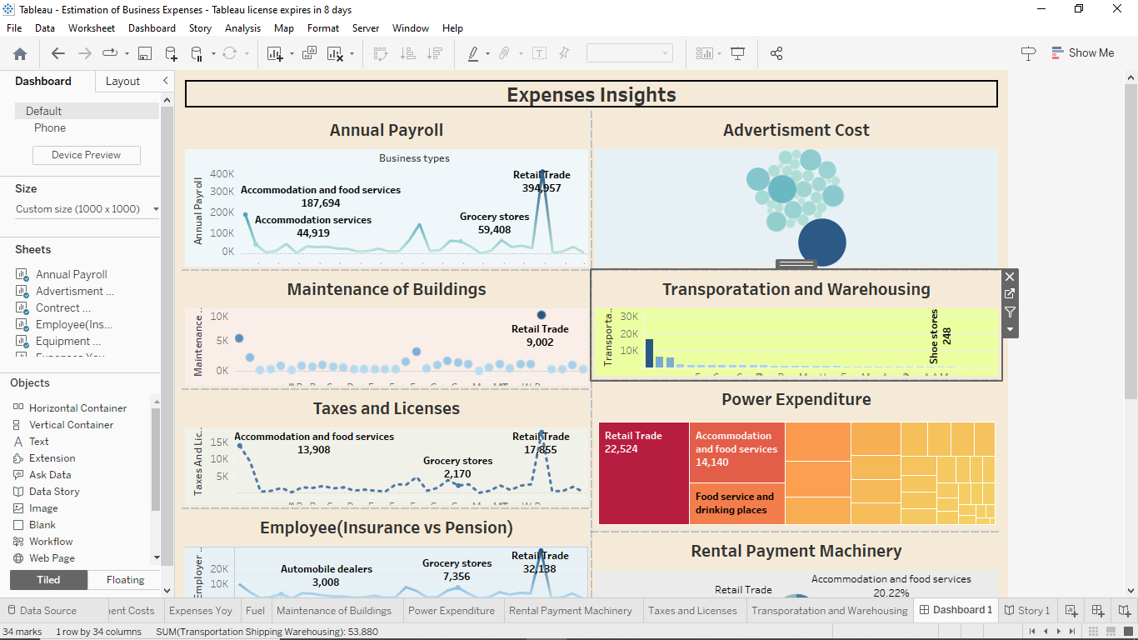

### 3.3 Story

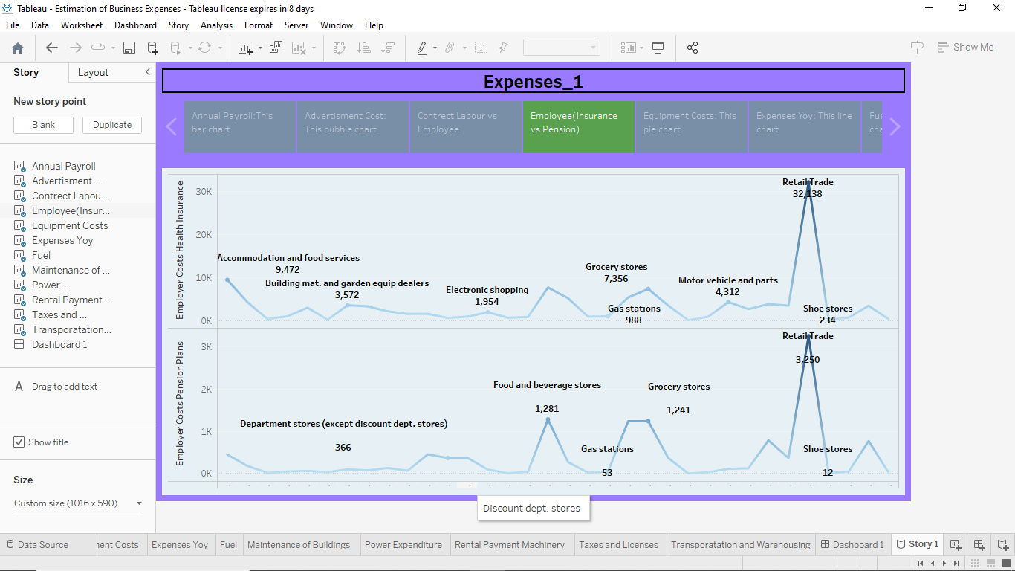

### 3.4 Performance Testing

**Amount of Data Rendered to Tableau:**

*The amount of data that is renderers to a Tableau is directly influenced by the dimensions of the dataset.

Utilization of Data Fitters:

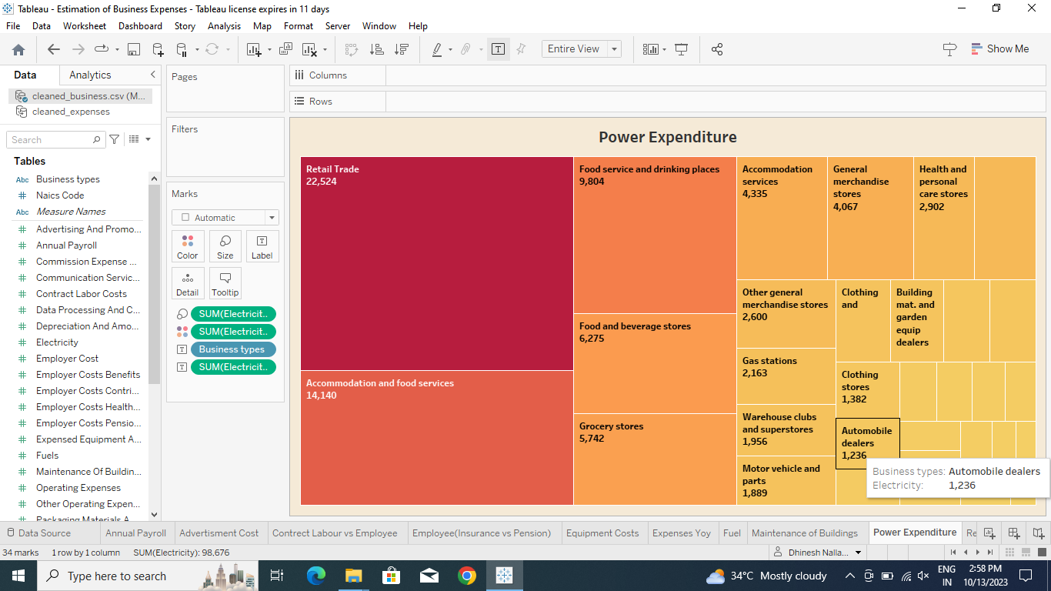

\***No of Visualizations/ Graphs:**

1. Annual Payroll

2. Advertisment Cost

3. Contrect Labour vs Employee

4. Employee (Insurance vs Pension)

5. Equipment Costs

6. Expenses Yoy

7. Fuel

8. Maintenance of Buildings

9. Power Expenditure

10. Rental Payment Machinery

11. Taxes and Licenses

12. Transportations and Warehousing

**4. ADVANTAGES & DISADVANTAGES**

### 4.1 Advantages

**Visual Clarity:** Tableau's visualizations provide a clear and intuitive way to understand complex data, facilitating better comprehension of spending behavior and growth opportunities.

**Interactive Exploration:** Tableau's interactive features allow users to explore data dynamically, encouraging a more thorough and customized analysis.

**Time Efficiency:** The tool enables quick data analysis and visualization, saving time in comparison to traditional methods, thus fostering timely decision-making.

**Holistic Insights:** Tableau allows for the integration of diverse data sources, providing a comprehensive view of market insights and spending behavior for a more holistic understanding.

**Effective Communication:** The visual nature of Tableau makes it easier to communicate findings and insights to stakeholders, fostering better collaboration and understanding.

### 4.2 Disadvantages

**Learning Curve:** Tableau has a learning curve, and users who are not familiar with the tool may require training to use it effectively, potentially slowing down the implementation process.

**Cost of Licensing:** Tableau licensing costs can be relatively high, especially for larger enterprises, which may pose a financial challenge for some organizations.

**Data Security Concerns:** Handling sensitive market data requires robust security measures. If not properly configured, Tableau deployments may pose data security risks.

**Dependency on Data Quality:** Tableau's effectiveness is highly dependent on the quality of the input data. Inaccurate or incomplete data may lead to misleading insights.

**Limited Offline Access:** Tableau is primarily an online tool, and while it offers some offline capabilities, full functionality often requires an internet connection, limiting accessibility in certain scenarios.

In conclusion, while Tableau offers powerful tools for market analysis and insights, organizations should carefully weigh the advantages and disadvantages to ensure it aligns with their specific needs and resources.

**5. APPLICATIONS**

The application of “Estimation of Business Expenses: Analyzing Spending Behavior and Identifying Opportunities for Growth using Tableau" spans across various business domains and functions, offering valuable insights for strategic decision-making. Here are some key applications:

* Business Segmentation
* Product Performance Analysis
* Promotional Effectiveness
* Geographical Expansion
* Customer Journey Mapping
* Competitor Analysis
* Supply Chain Optimization
* Financial Performance Analysis

The versatile nature of Tableau allows organizations to apply market insights in a multitude of ways, making it a powerful tool for informed decision-making across different facets of business operations.

**6. CONCLUSION**

The "Estimation of Business Expenses" project successfully utilized Tableau to analyze spending behavior, identify opportunities for growth, and provide actionable insights for strategic decision-making. The findings and recommendations outlined in this report serve as a valuable resource for stakeholders aiming to enhance market competitiveness and drive sustainable business growth.

This project underscores the importance of leveraging advanced analytics tools like Tableau to unlock the full potential of data, transforming it into a strategic asset for organizations in a rapidly evolving market landscape.

**7. FUTURE SCOPE**

The future scope of Estimation of Business Expenses using Tableau is likely to be characterized by advancements in AI, real-time analytics, data security, and improved user experiences. As the field of data visualization and analytics continues to evolve, Tableau is poised to play a crucial role in empowering organizations with actionable insights for strategic decision-making.